**Chapter 5**

**THE SOURCE CODES**

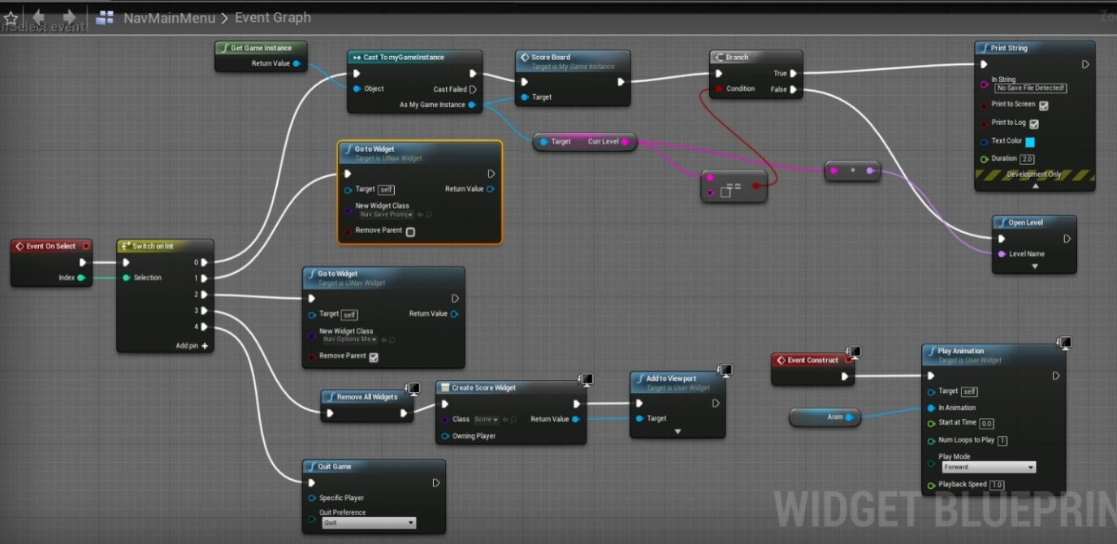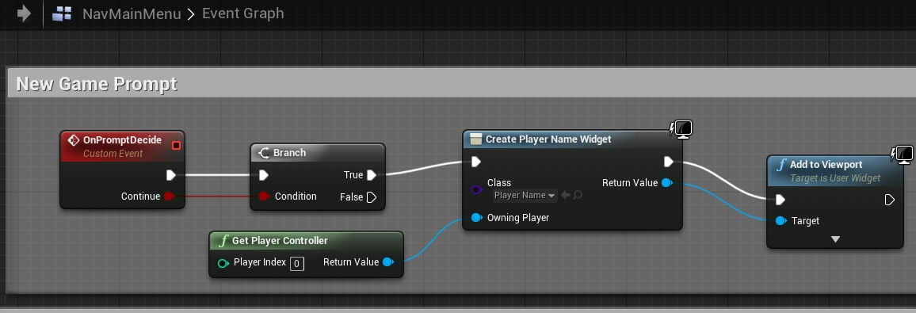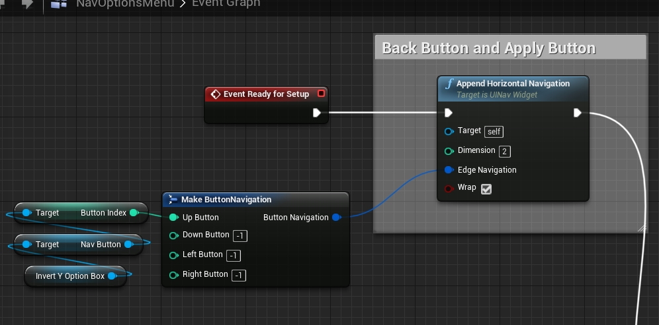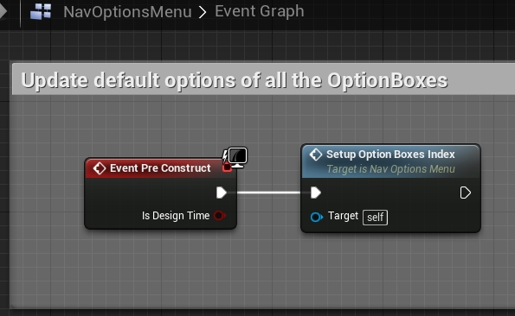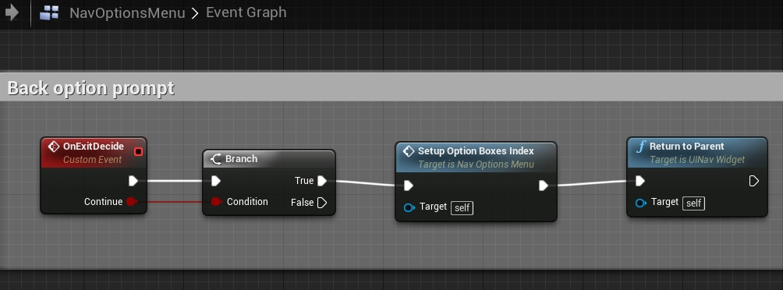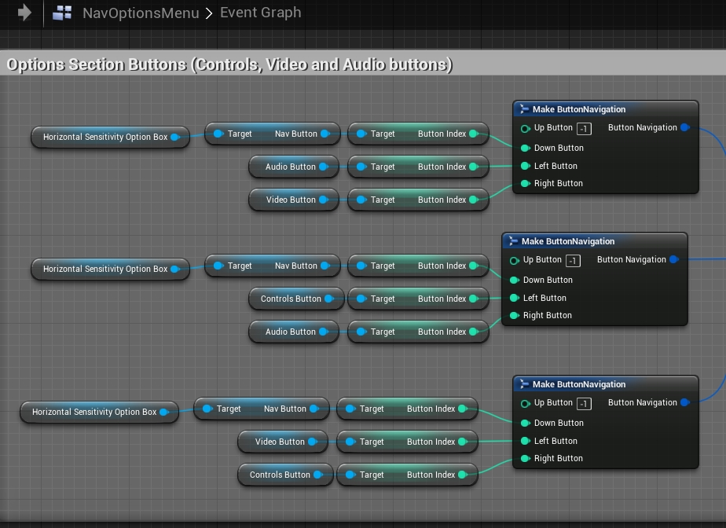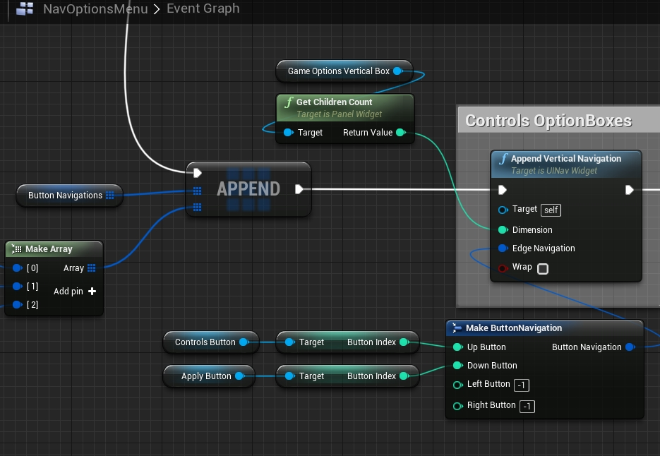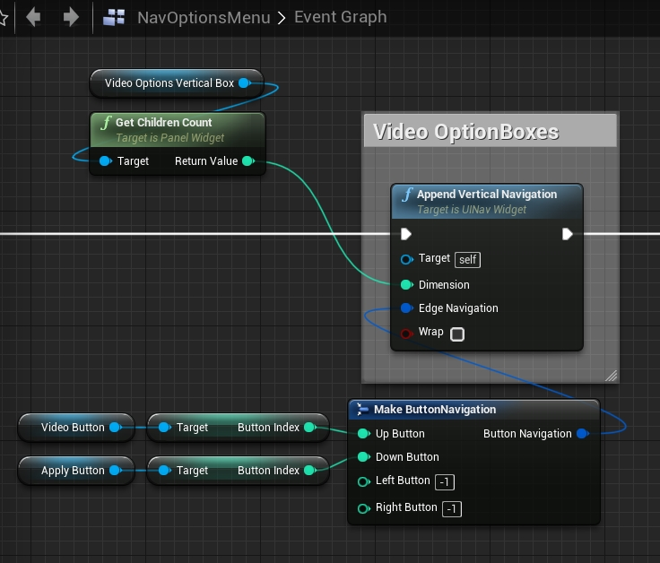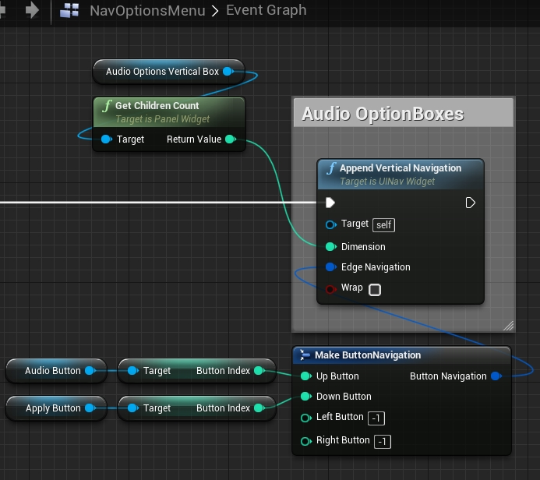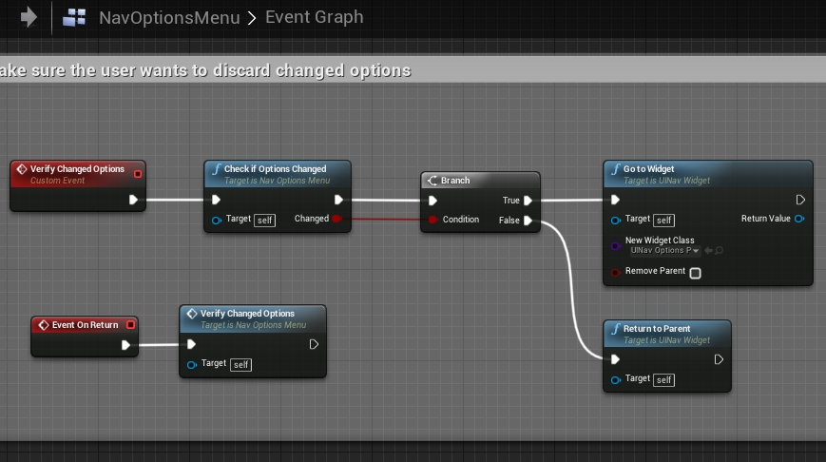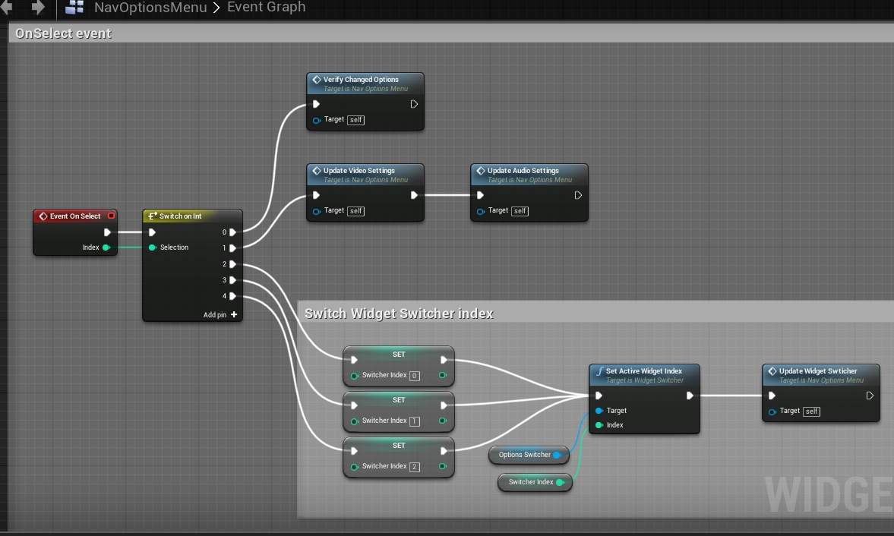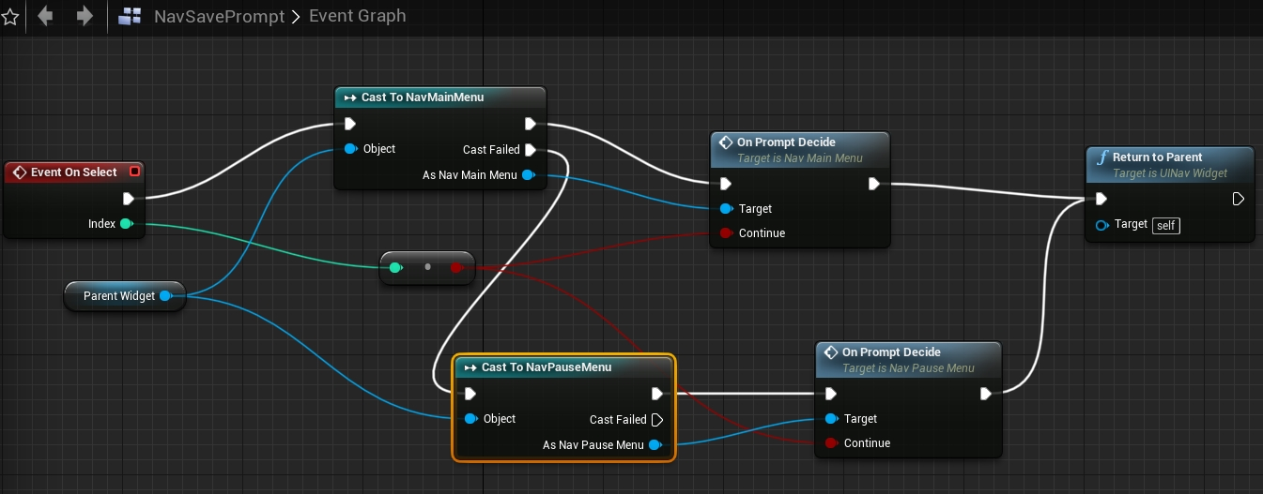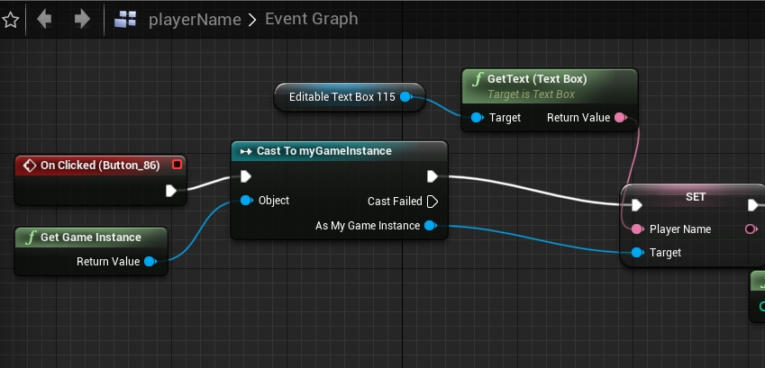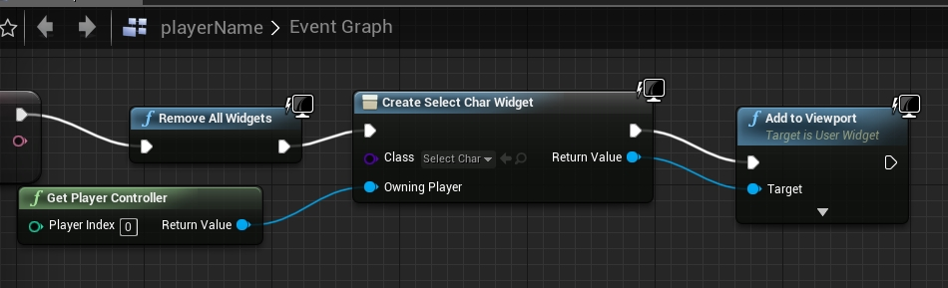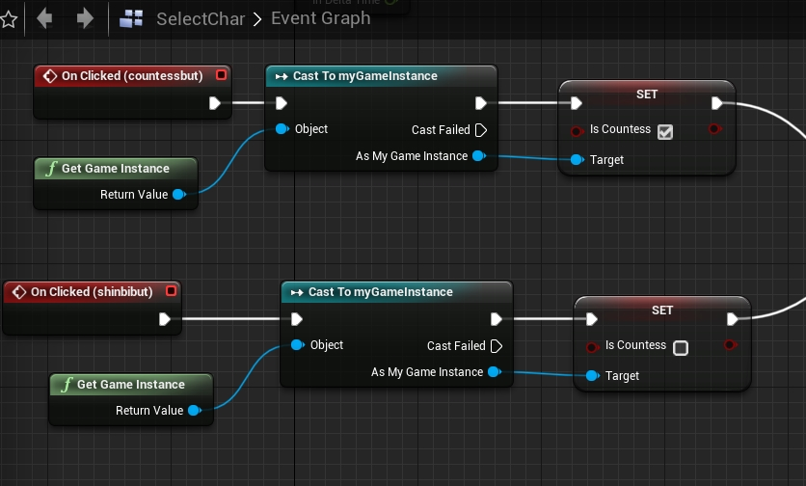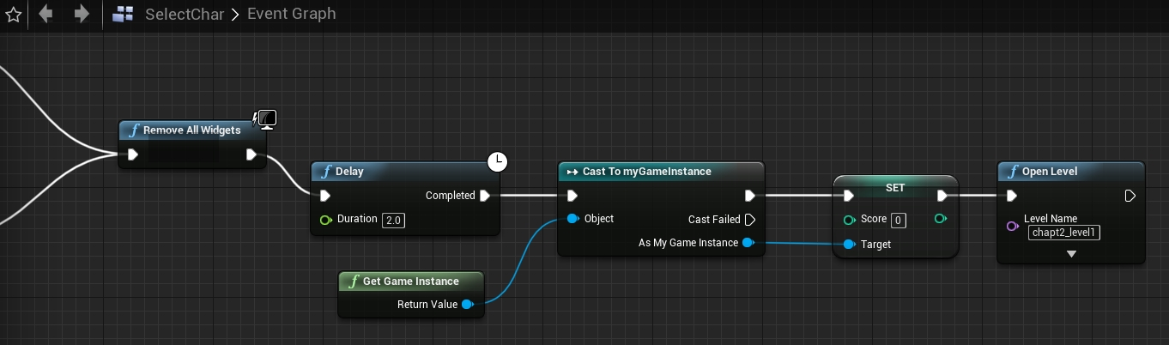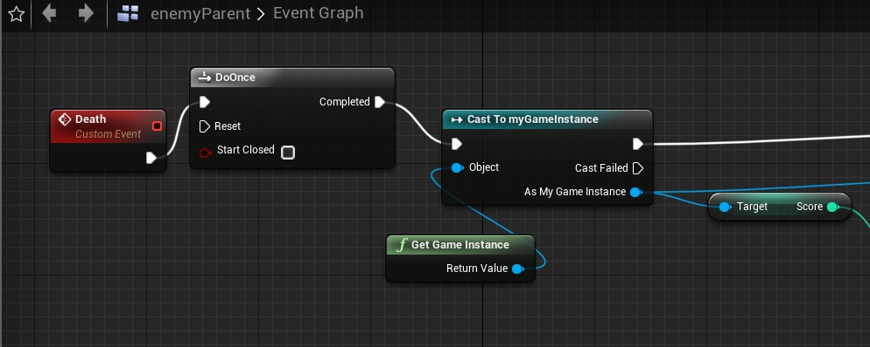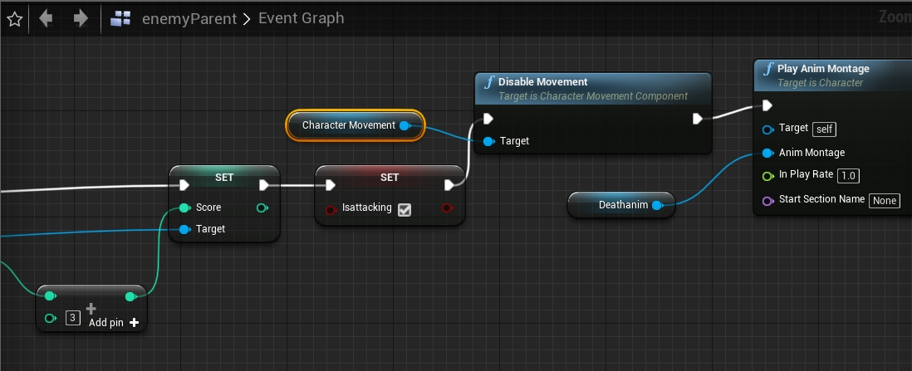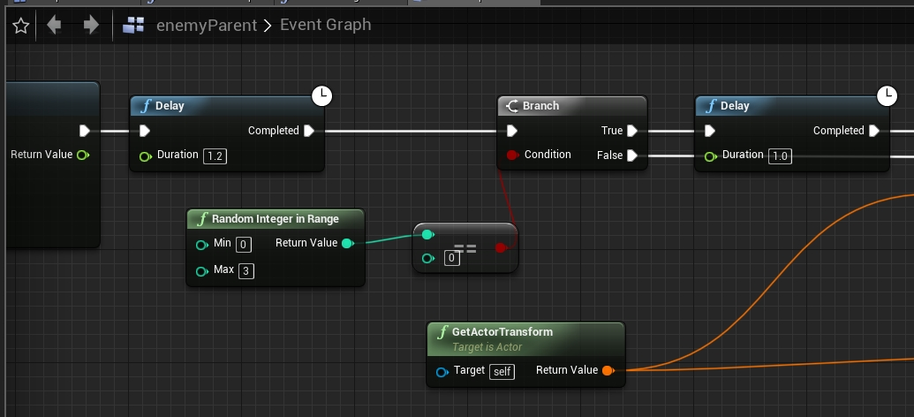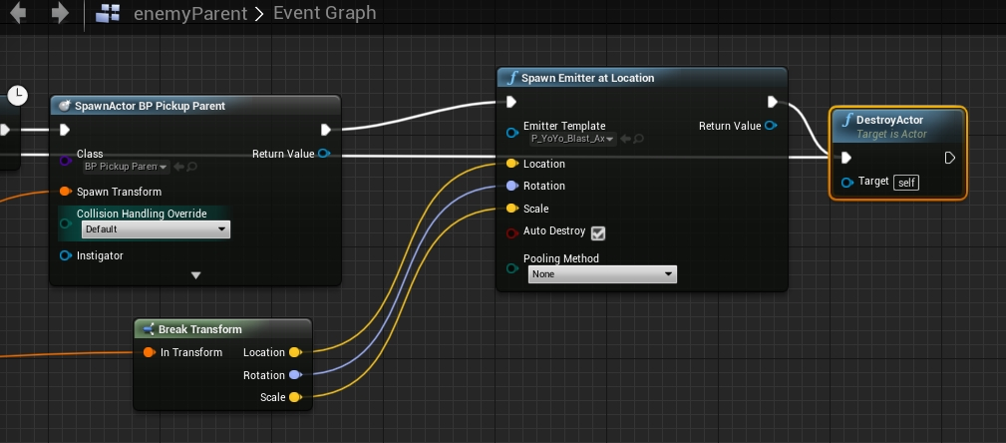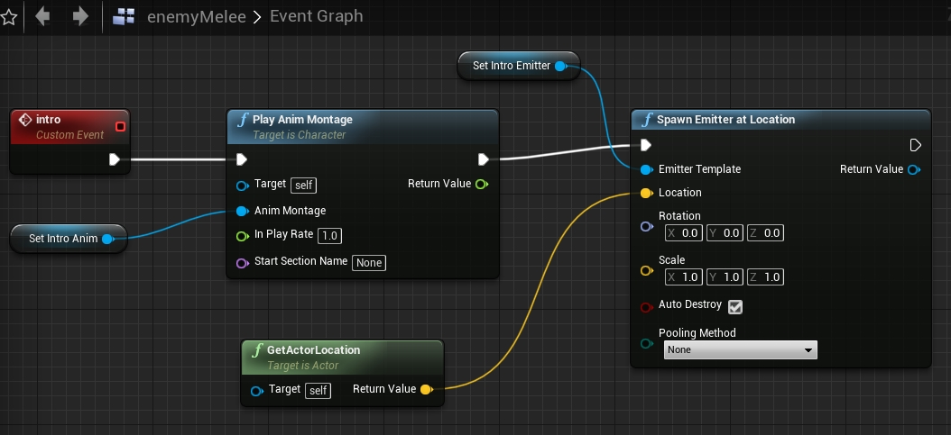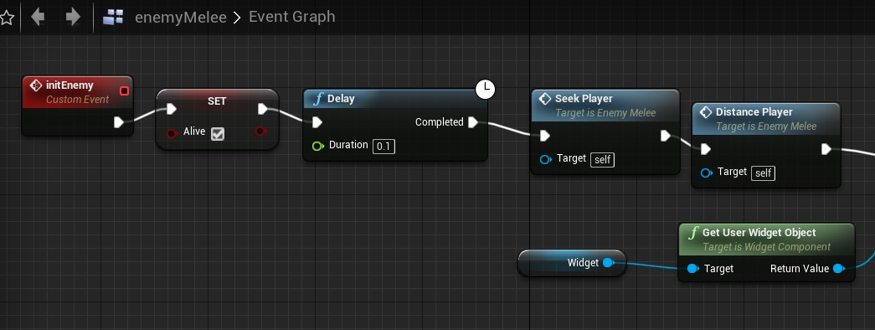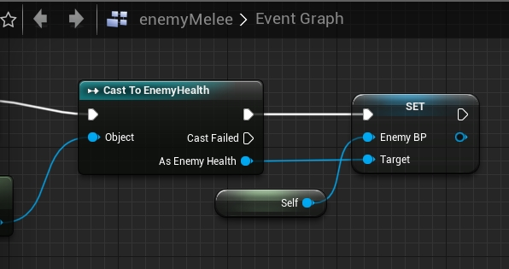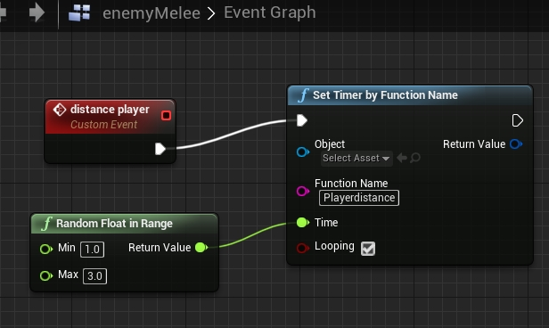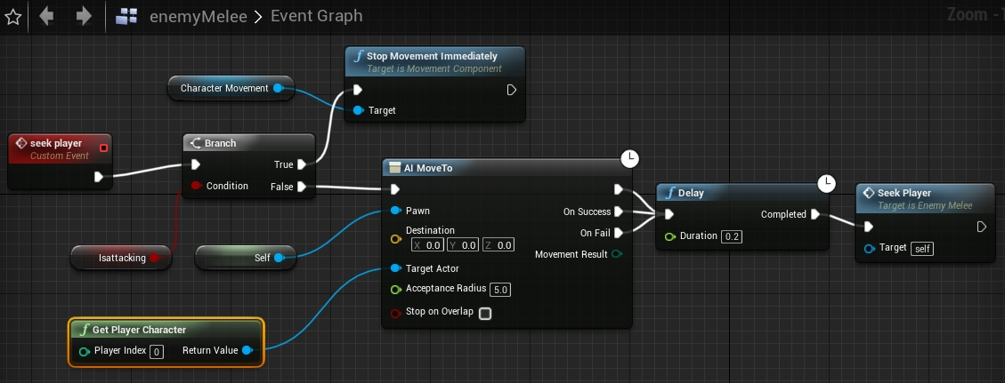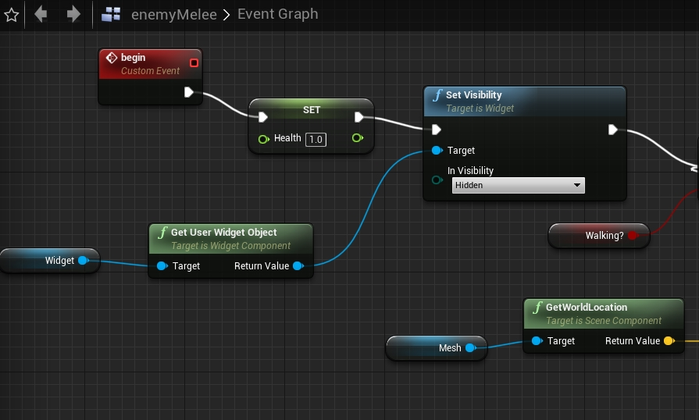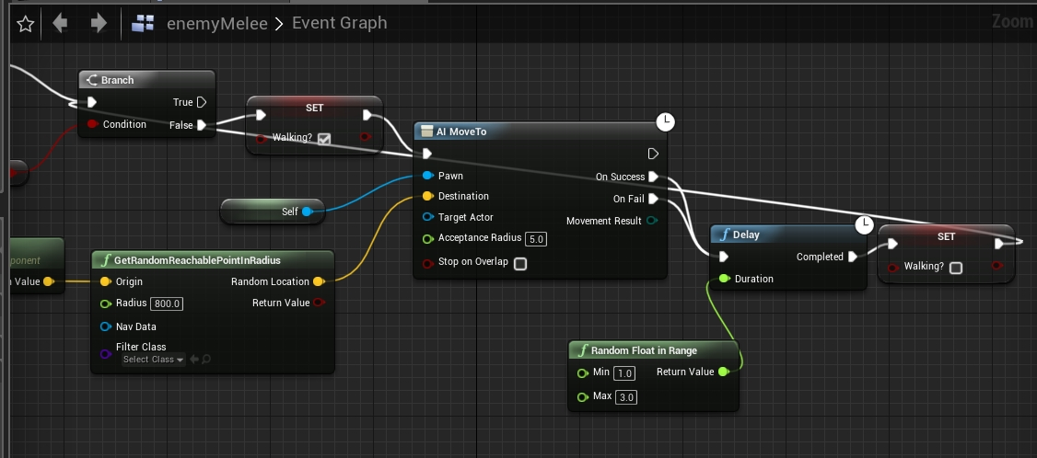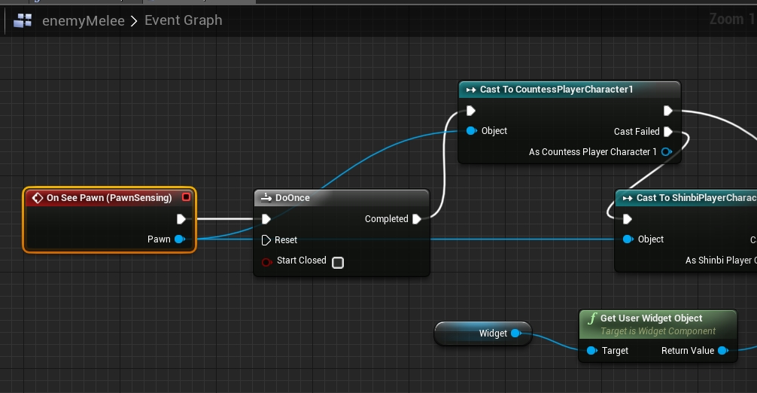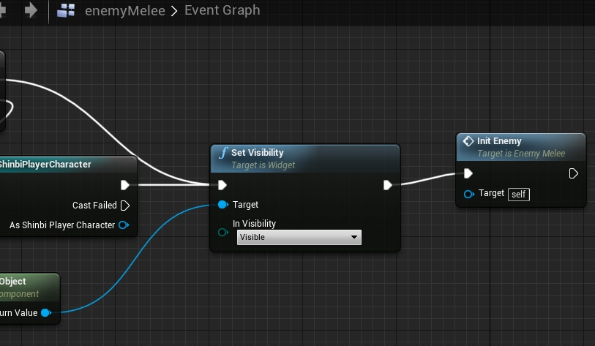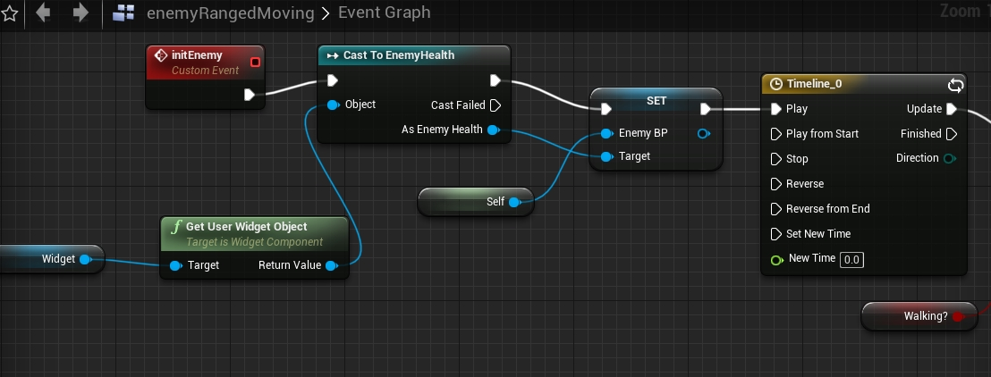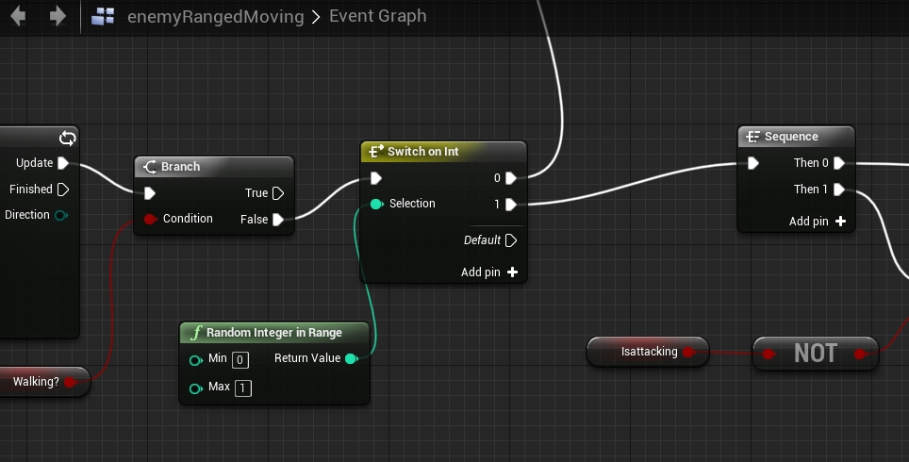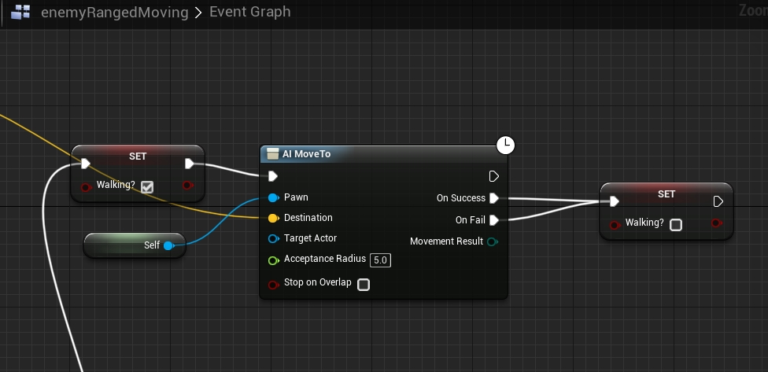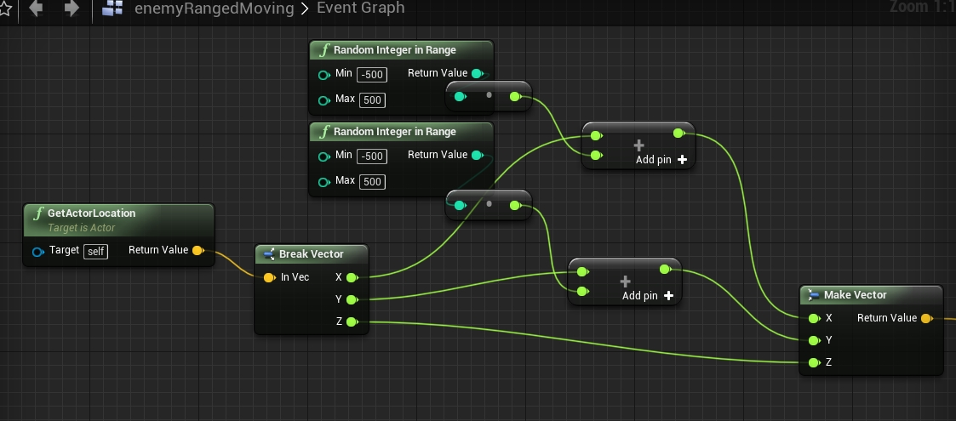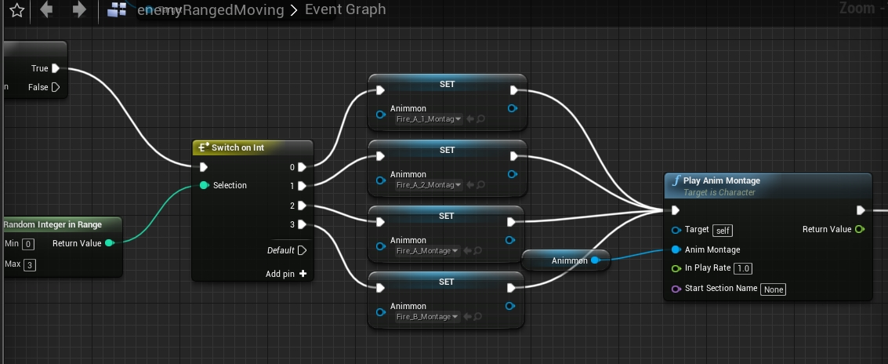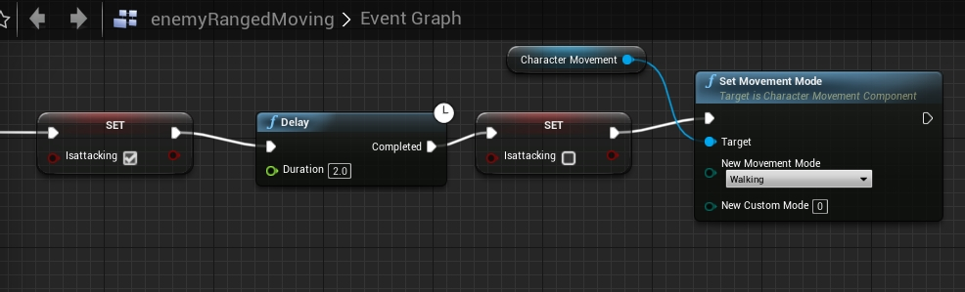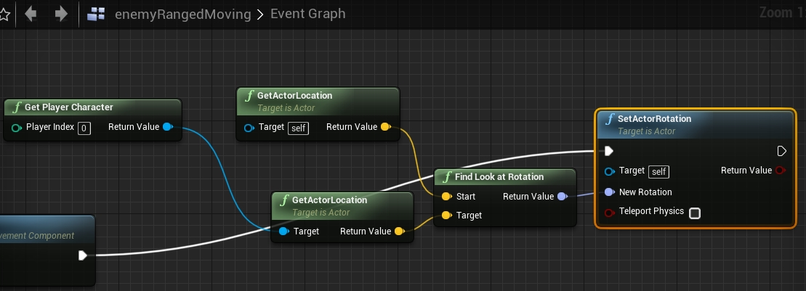

**References**

Virtus Learning Hub (2018). Unreal RPG guide. Retrieved from [https://youtube.com/channel/UCz-eYJAUgSE-mqzKtit7m9g on September 8](https://youtube.com/channel/UCz-eYJAUgSE-mqzKtit7m9g%20on%20September%208), 2018.

Virtus Learning Hub (2018). Unreal AI guide. Retrieved from[https://youtube.com/channel/UCz-eYJAUgSE-mqzKtit7m9g on September](https://youtube.com/channel/UCz-eYJAUgSE-mqzKtit7m9g%20on%20September)9, 2018.

Virtus Learning Hub (2018). Unreal Game Mechanics. Retrieved from [https://youtube.com/channel/UCz-eYJAUgSE-mqzKtit7m9g on September](https://youtube.com/channel/UCz-eYJAUgSE-mqzKtit7m9g%20on%20September%208) 9, 2018.

Virtus Learning Hub (2018). Melee Weapons for Unreal RPG. Retrieved from [https://youtube.com/channel/UCz-eYJAUgSE-mqzKtit7m9g on](https://youtube.com/channel/UCz-eYJAUgSE-mqzKtit7m9g%20on%20) September 26, 2018.

Virtus Learning Hub (2018). Unreal Engine Blueprint system. Retrieved from [https://youtube.com/channel/UCz-eYJAUgSE-mqzKtit7m9g on September](https://youtube.com/channel/UCz-eYJAUgSE-mqzKtit7m9g%20on%20September%208) 8, 2018.

Virtus Learning Hub (2018). Unreal Engine Assets Guide. Retrieved from [https://youtube.com/channel/UCz-eYJAUgSE-mqzKtit7m9g on September](https://youtube.com/channel/UCz-eYJAUgSE-mqzKtit7m9g%20on%20September%208) 11, 2018.

Virtus Learning Hub (2018). Projectile and Weapons guide for Unreal Engine. Retrieved from [September](https://youtube.com/channel/UCz-eYJAUgSE-mqzKtit7m9g%20on%20August) 20, 2018

**Appendices**

1. **Letters to the Company**

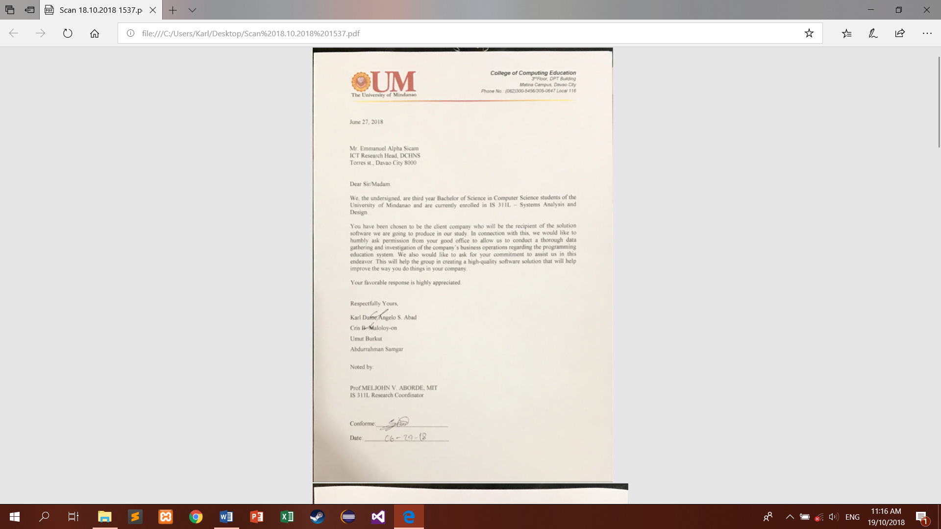

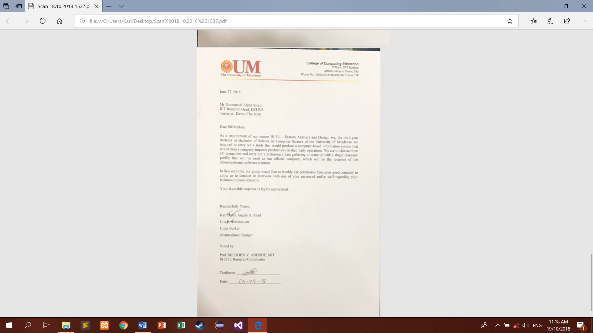

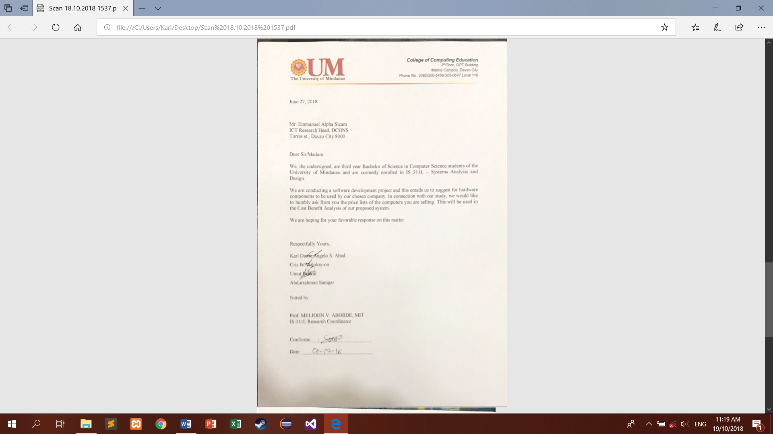

1. **Survey and Interview Questionnaire**

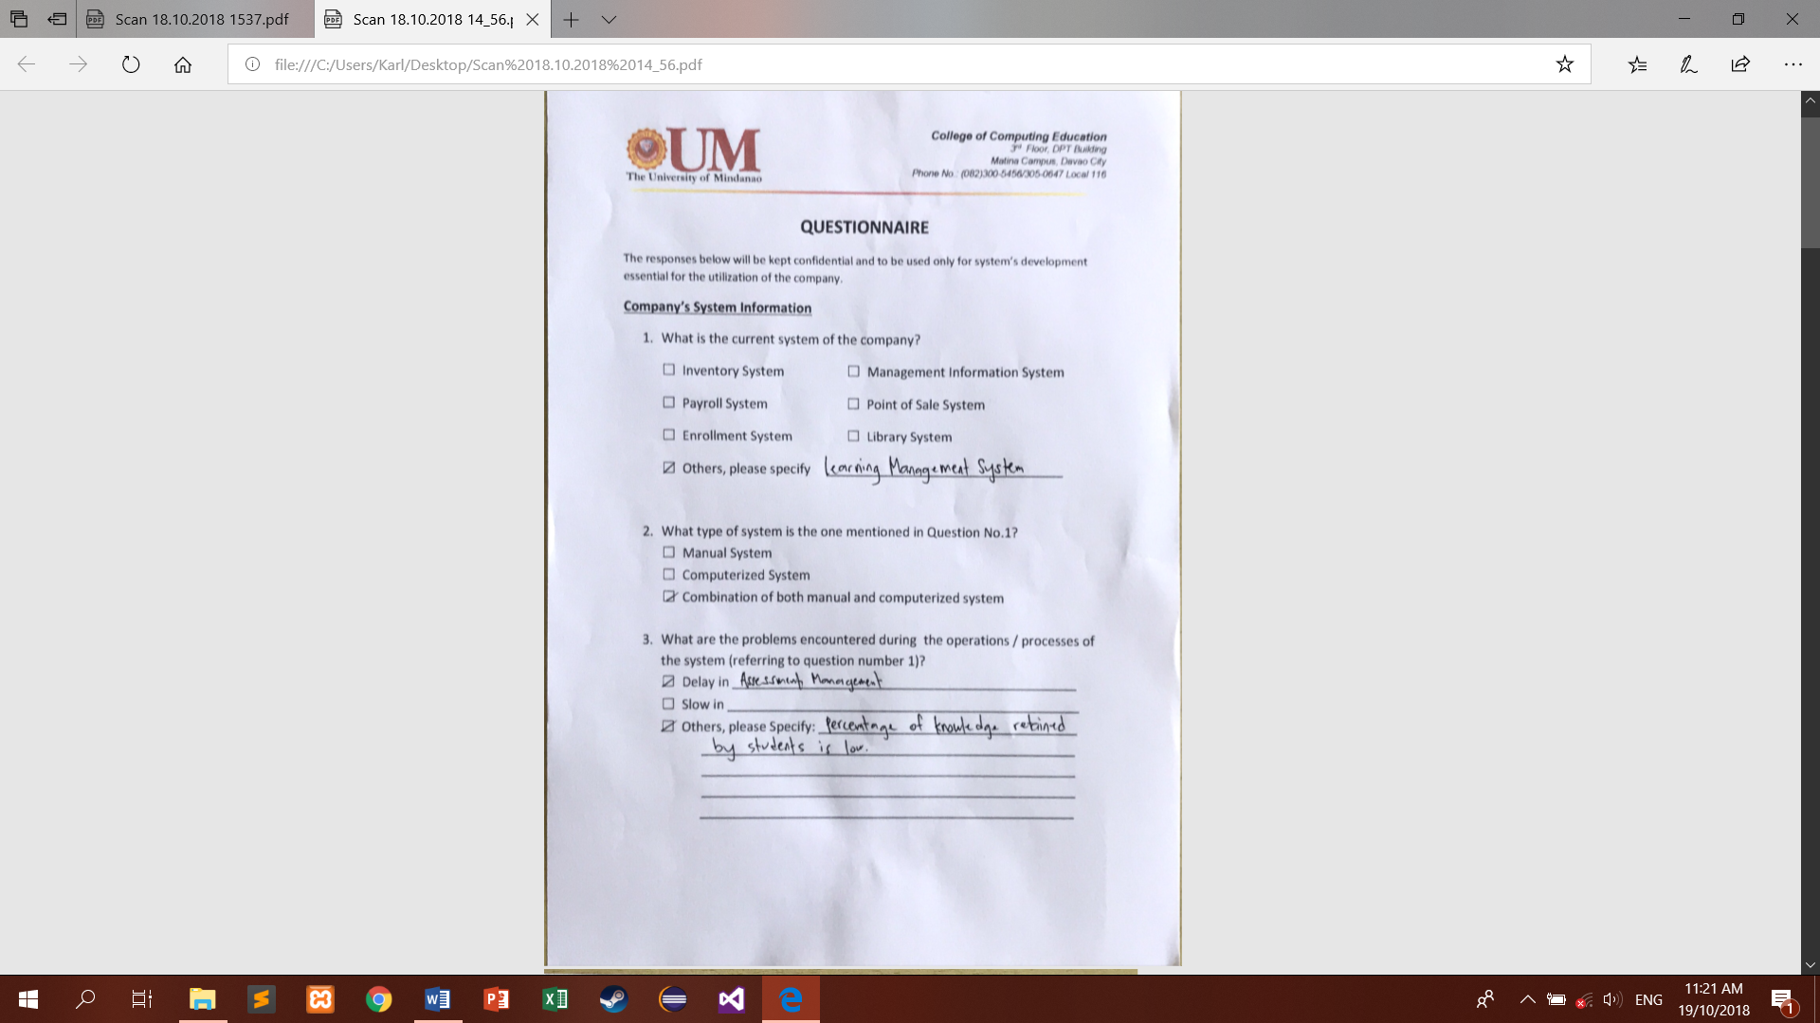

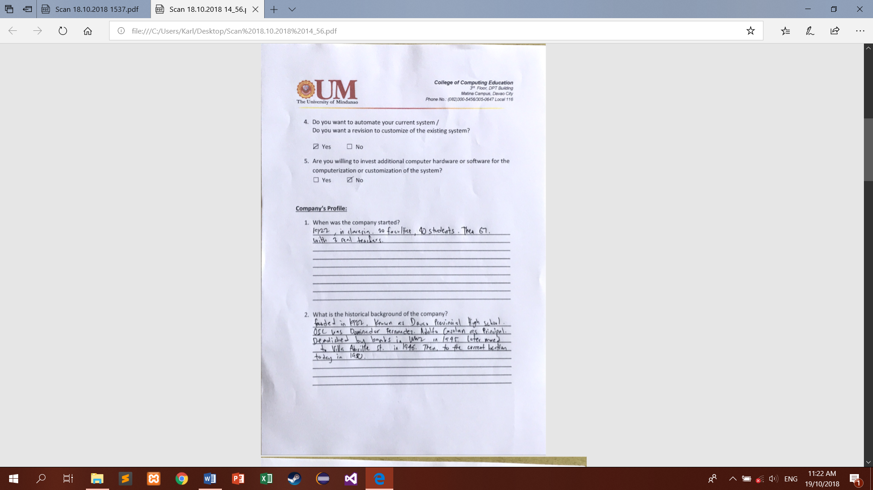

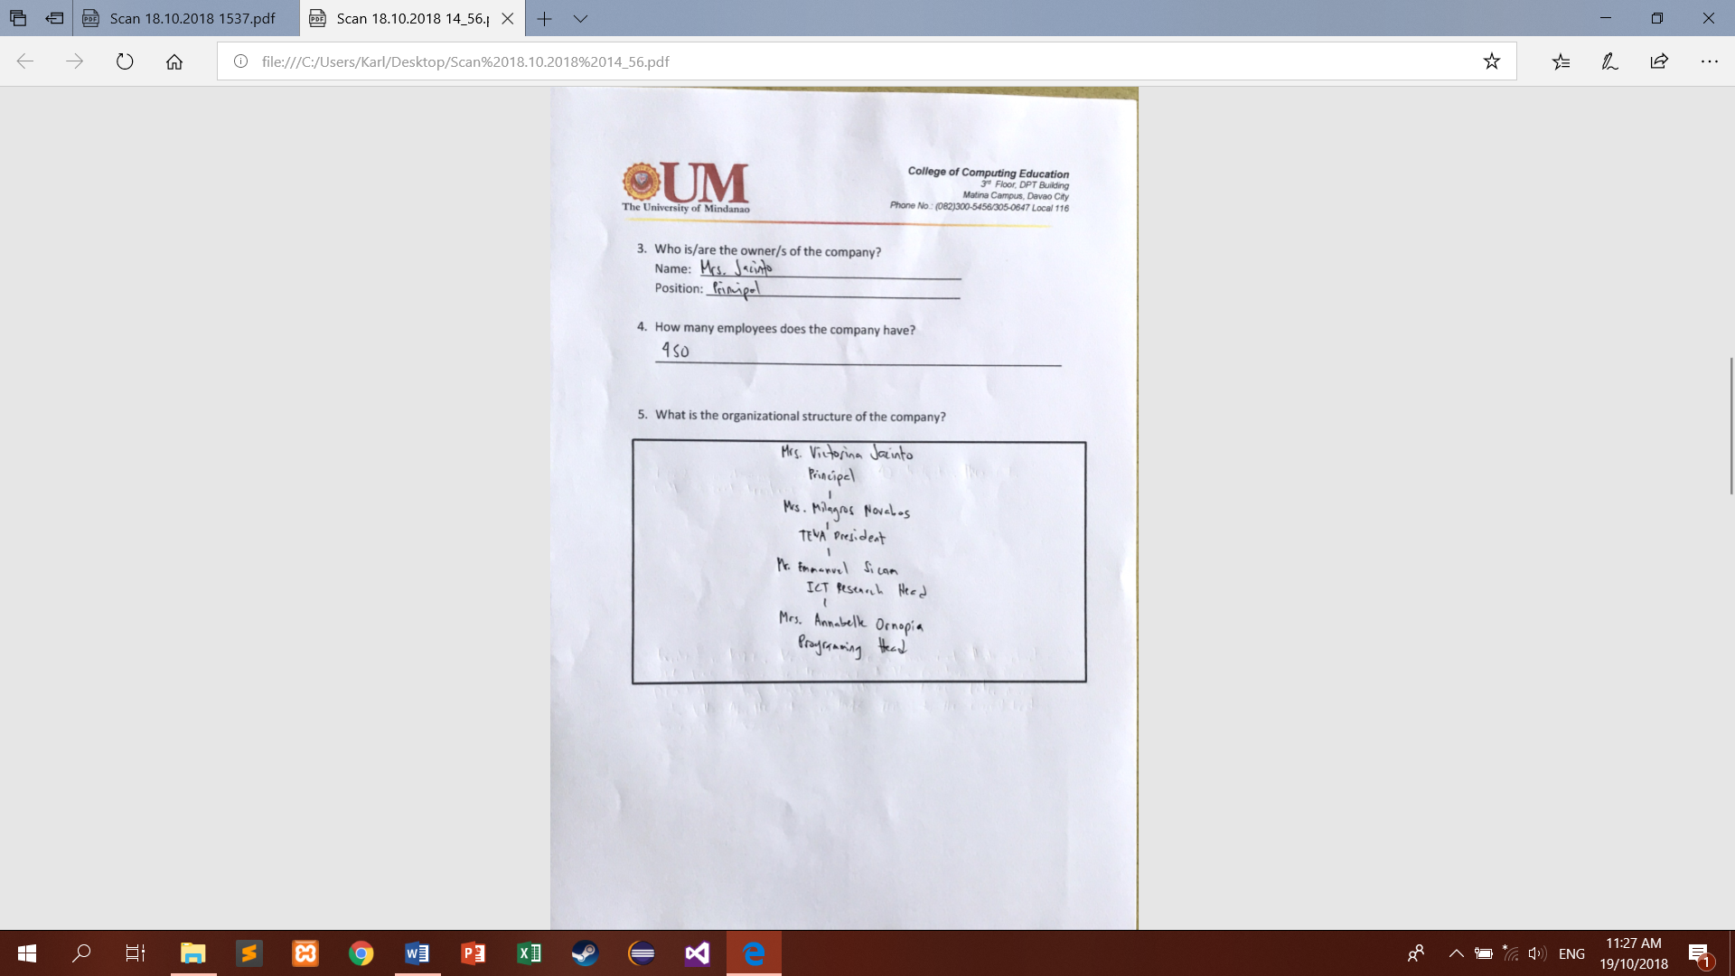

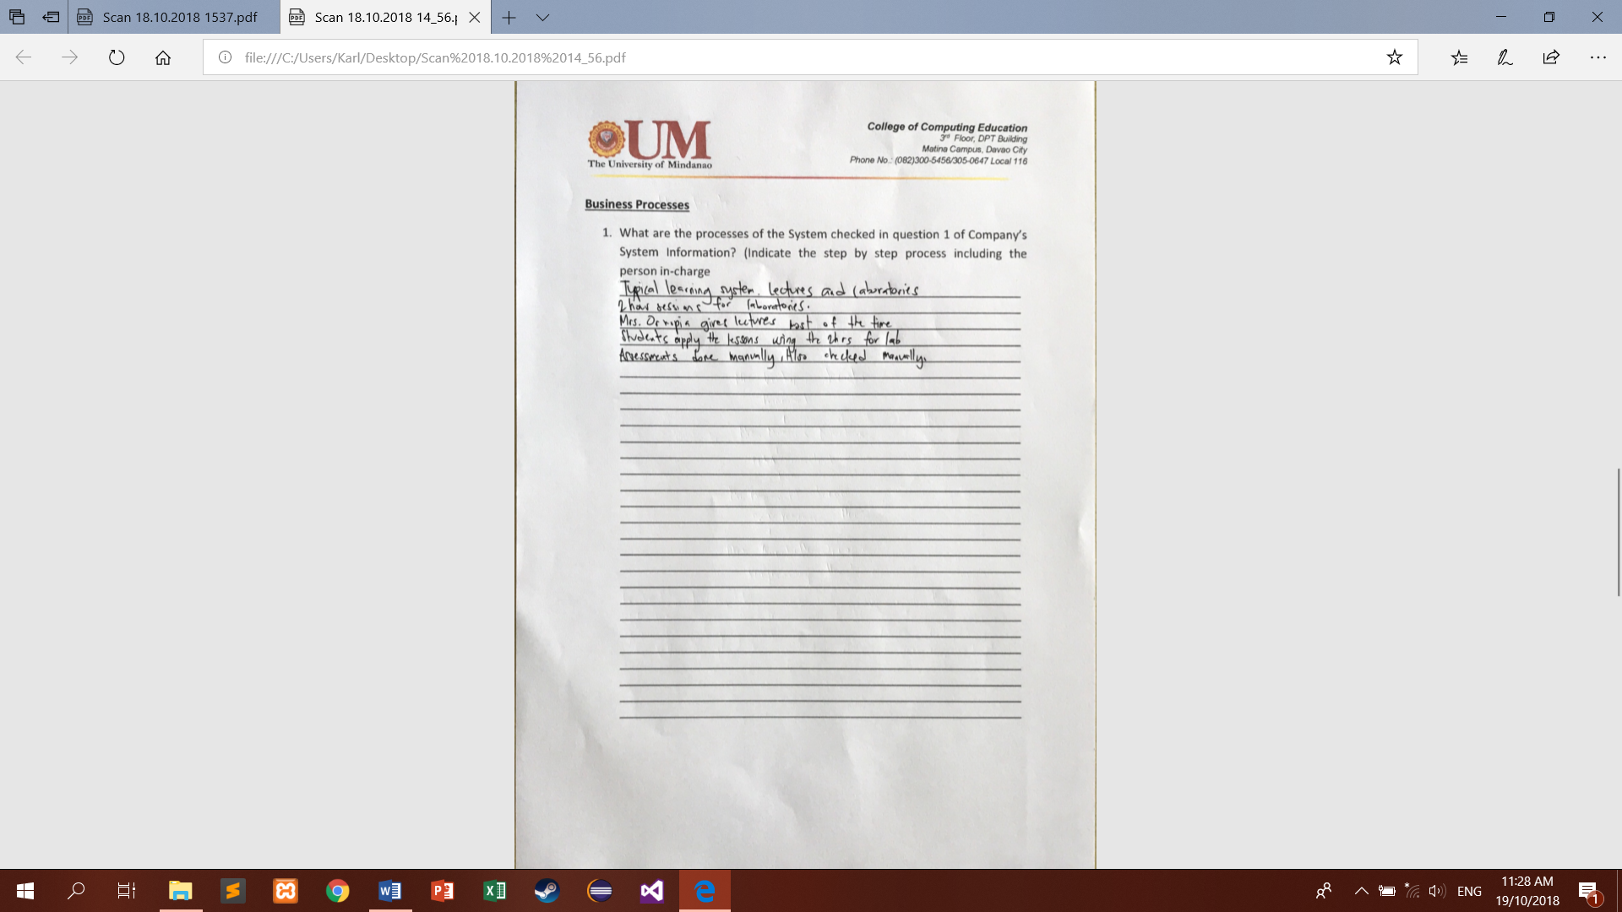

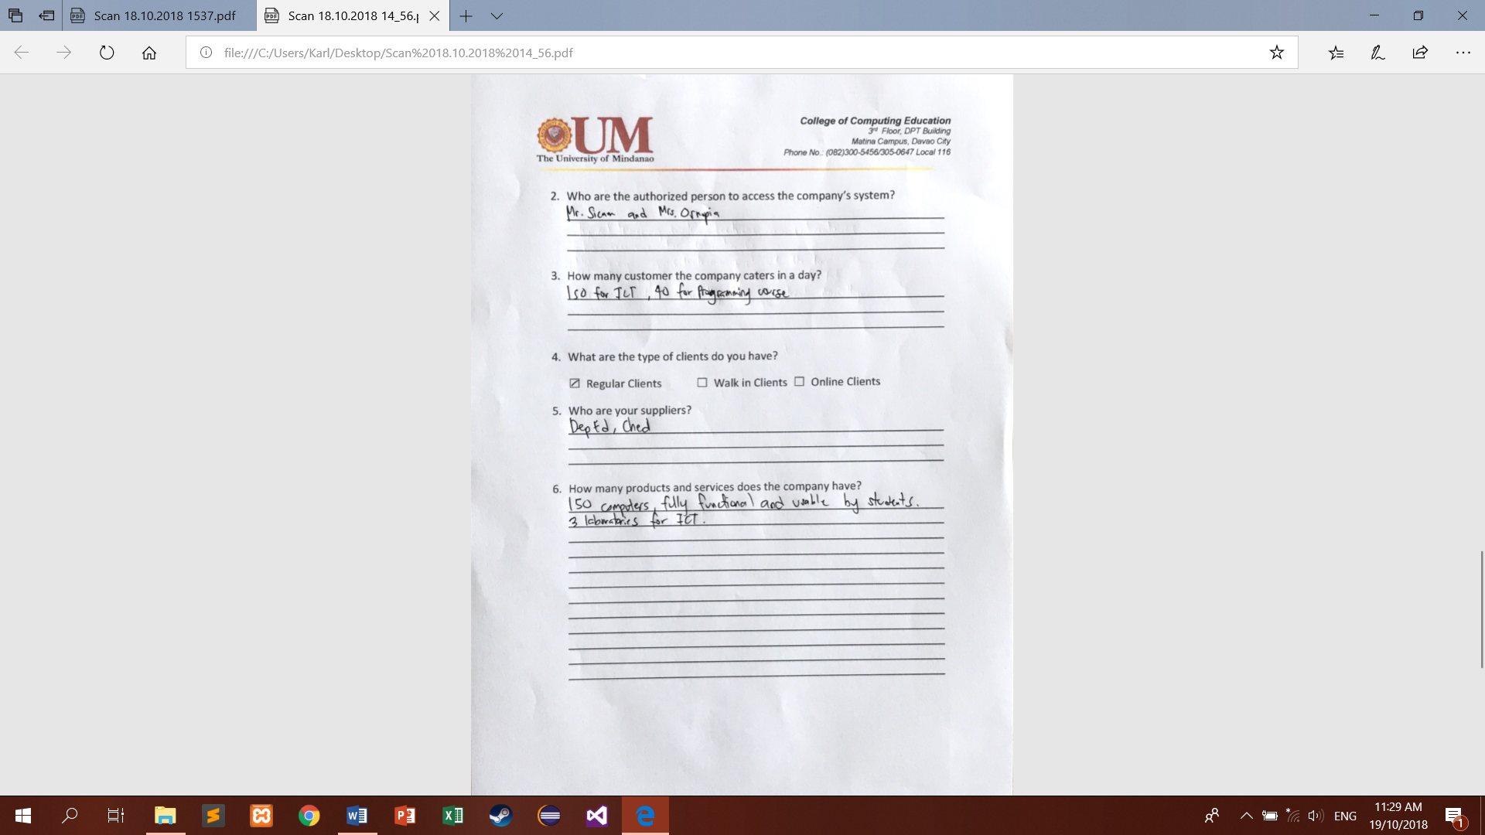

1. **Letter to the Consultant**

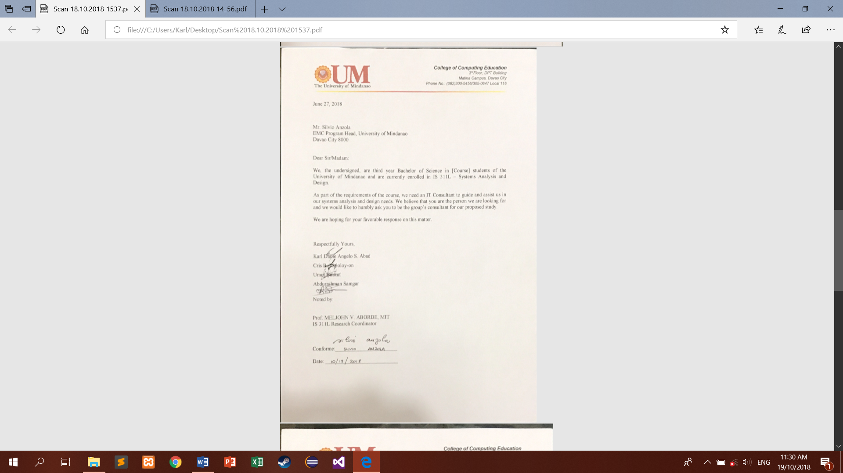

1. **Rubrics**

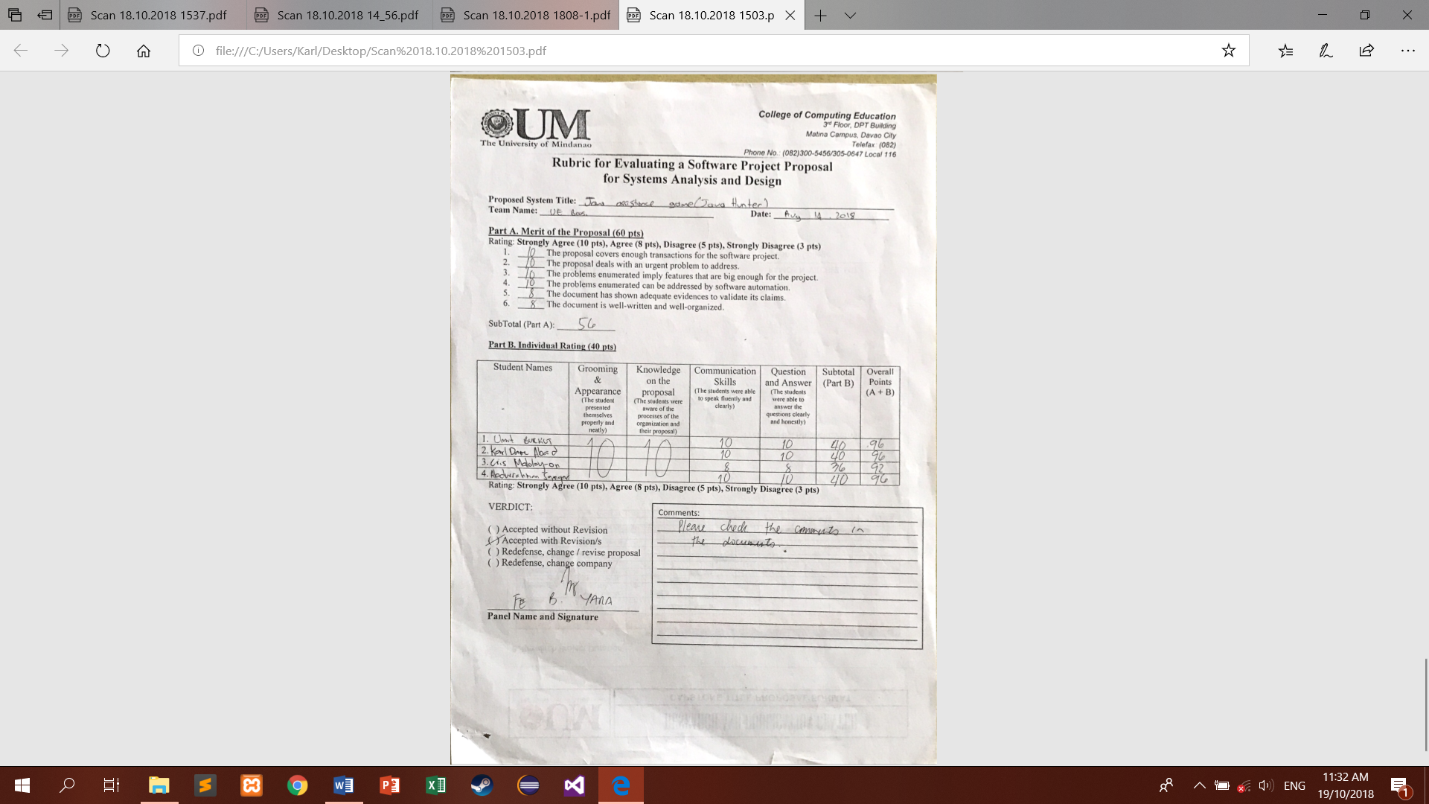

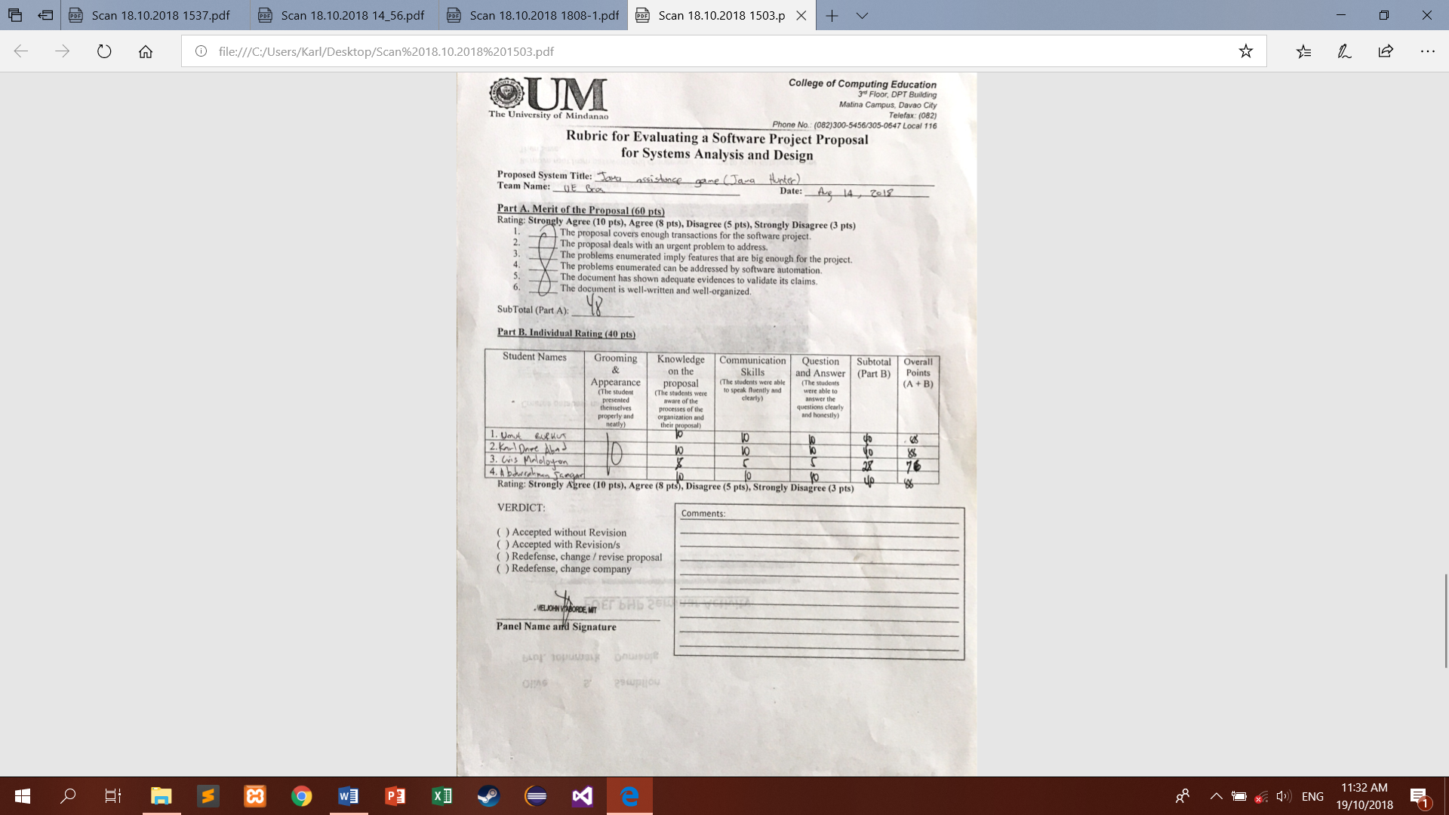  
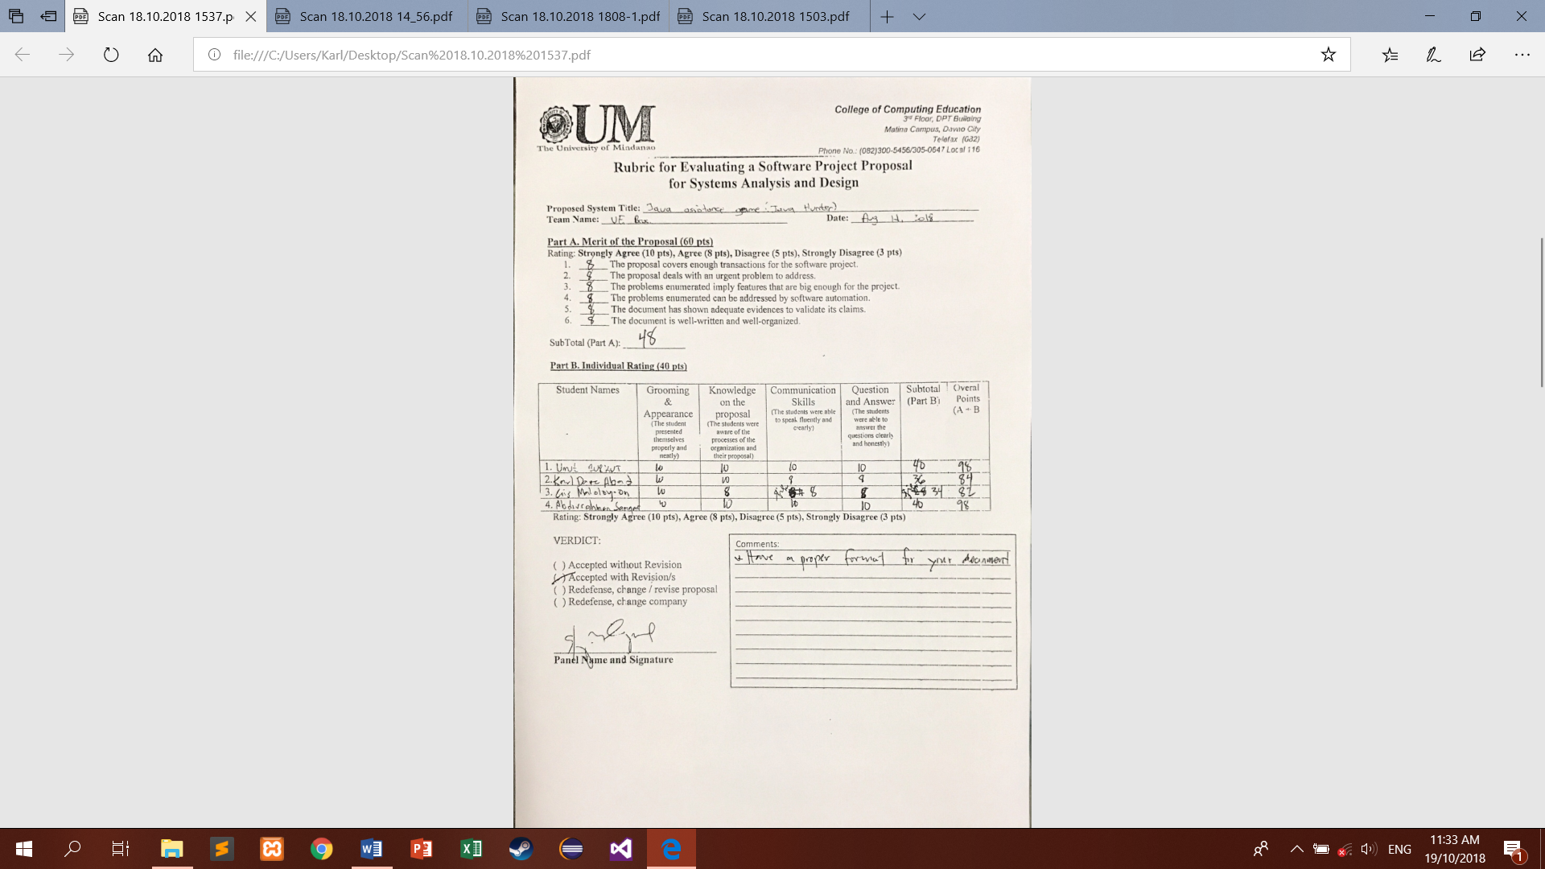

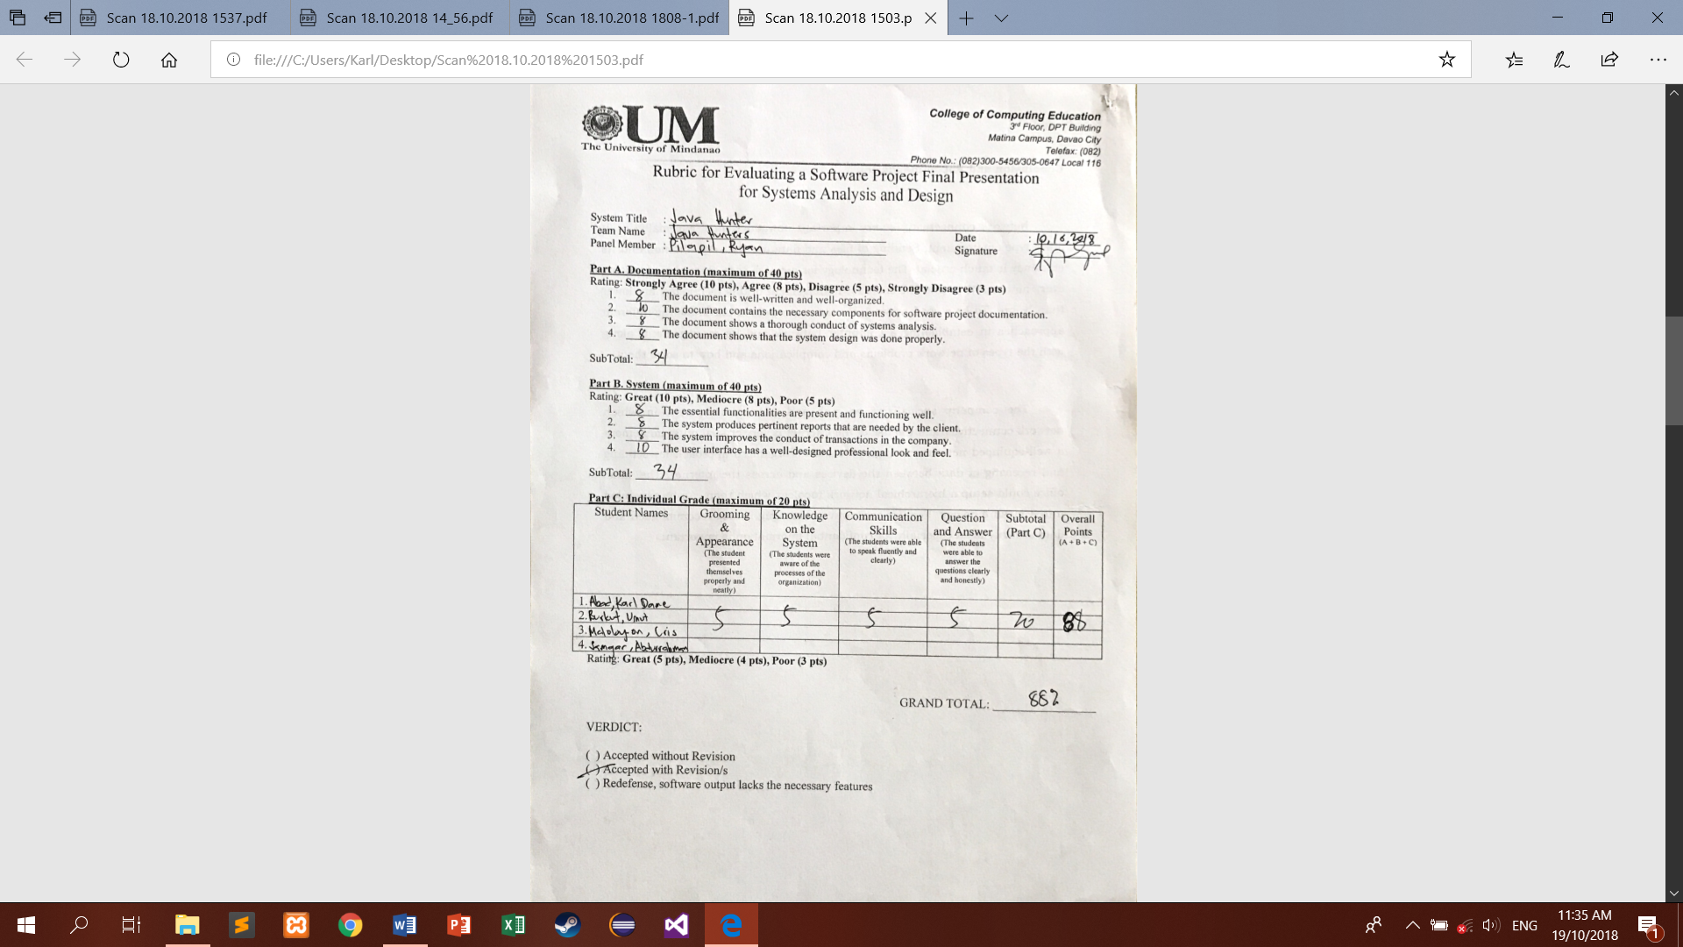

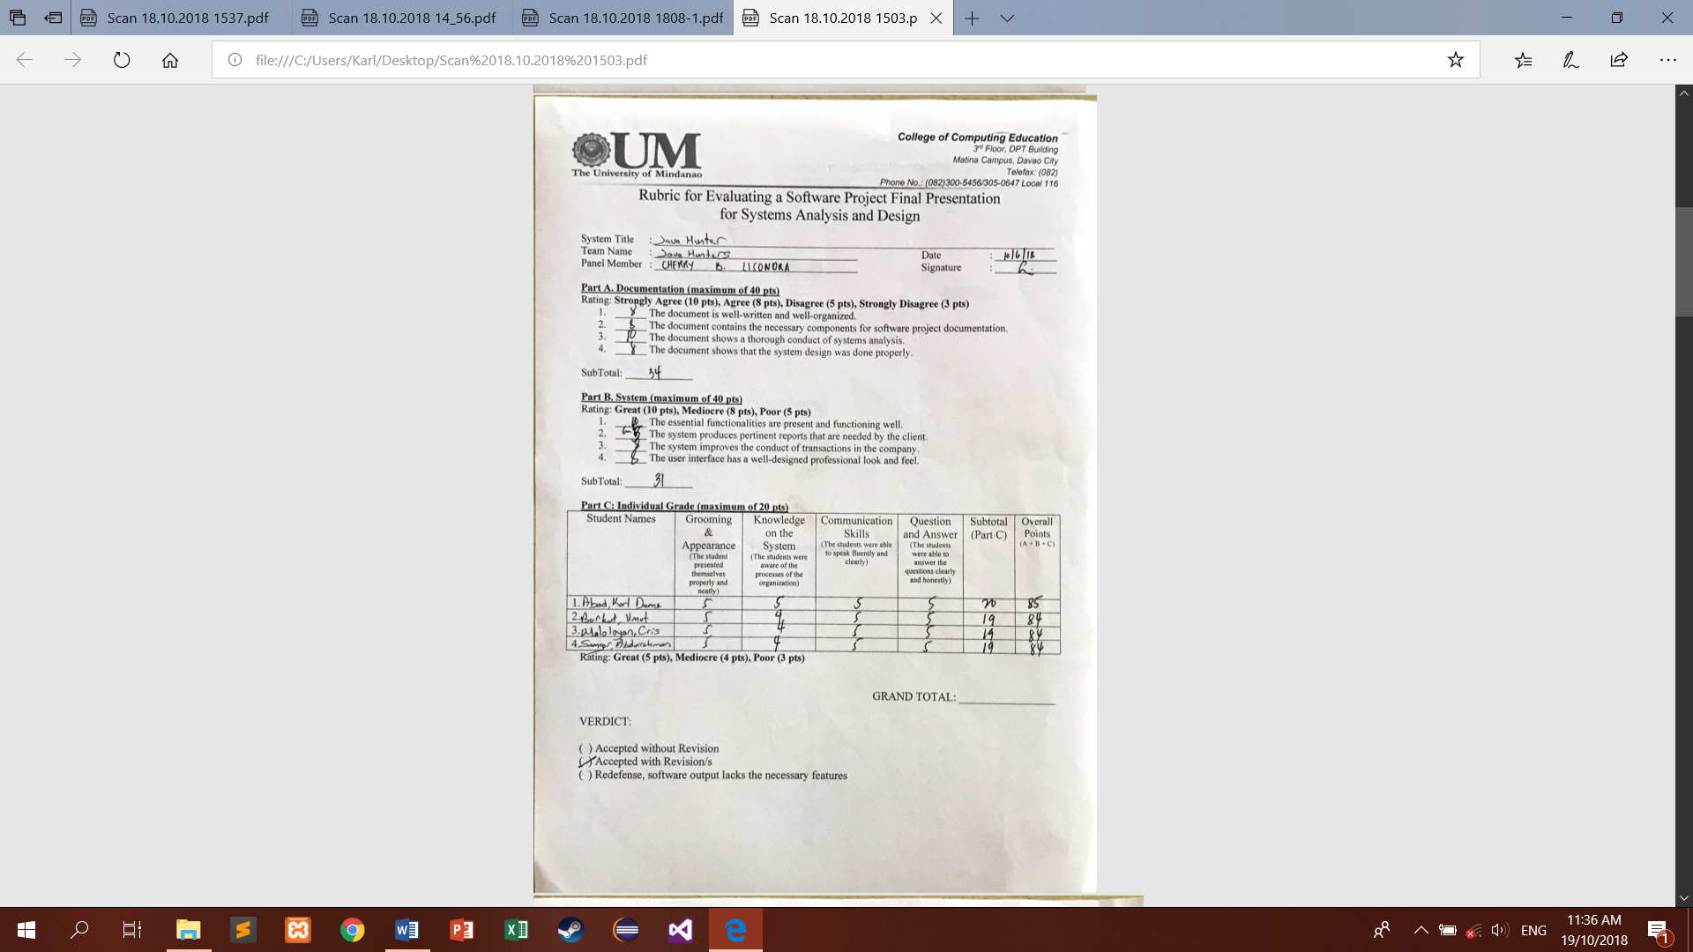

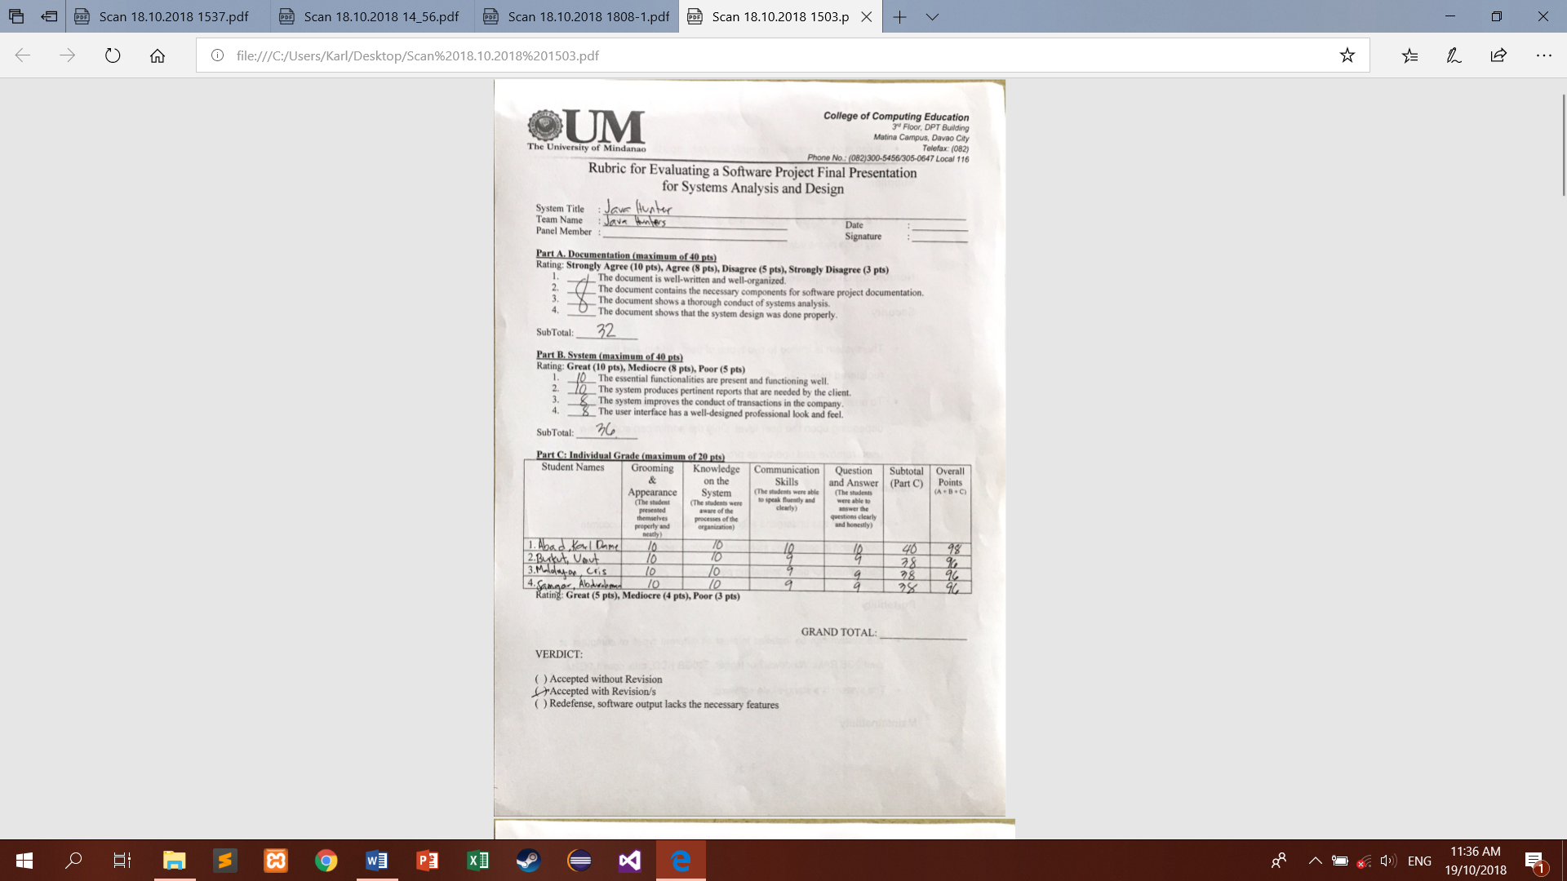

1. **Curriculum Vitae**



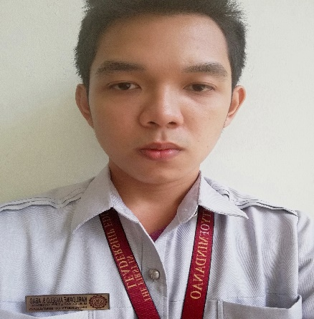

**Karl Dame Angelo S. Abad**

Address 1: Km.8 Buhangin, Davao City  
Address 2: Koronadal City, South Cotabato  
Mobile:+639171289792   
Email: karldame.abad17@gmail.com

| EDUCATION |  |
| --- | --- |
| **University of Mindanao (Matina, Davao City) - Tertiary** | 2015-Present |
| **Notre Dame Siena School of Marbel (Koronadal City) - Secondary** | 2009-2013 |

| ELIGIBILITY & CERTIFICATIONS |  |
| --- | --- |
| Microsoft Office Specialist (MS PowerPoint) | 2016 |

| TRAININGS / SEMINARS / CONFERENCES |  |
| --- | --- |
| 1. PARTICIPANT    * **Provincial Youth Conference**   Gumasa Glan, Saranggani Province | August 26, 2012 |
| 1. PARTICIPANT  * **Reproductive Health Seminar**   Tigatto, Davao City | September 16, 2013 |
| 1. PARTICIPANT  * **Cybersecurity Caravan**   Ateneo de Davao University, Davao City | July 30, 2017 |



**University of Mindanao**

College of Computing Education

**Cris B. Maloloy-on**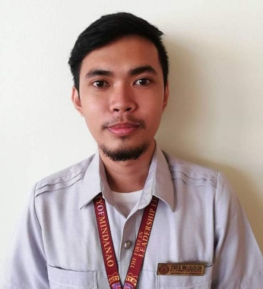

Address 1: Rosalsubd. San Vicente, Panabo City  
Address 2: Bolton Ext. Davao City  
Mobile: +639506457720  
Email: hyd3r.exe@gmail.com

| EDUCATION |  |
| --- | --- |
| **Panabo Christian School**  **Davao del Norte State College**  **University of Mindanao** | 2003-2009  2009-2013  2016-present |

| ELIGIBILITY & CERTIFICATIONS |  |
| --- | --- |
| * Microsoft Office Specialist | 2017 |



**University of Mindanao**

College of Computing Education

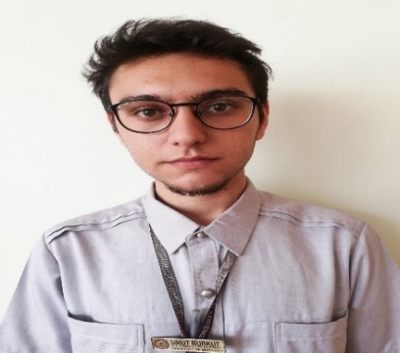**Umut Burkut**

Address 1: 106 JunaSubd.  
Address 2: Davao City  
Mobile:+639984264659   
Email: panimo.games@gmail.com

| EDUCATION |  |
| --- | --- |
| **SabihaGokcen Technical and Industrial Vocational HS** | 2011-2015 |
| **BS-Computer Science – University Of Mindanao** | 2015- |

| ELIGIBILITY & CERTIFICATIONS |  |
| --- | --- |
| * Certificate of Appreciation for 5th International Mobility Day | March 08, 2018 |

| TRAININGS / SEMINARS / CONFERENCES |  |
| --- | --- |
| 1. PARTICIPANT    * **TUROG Oracle Orientation**   Electrical Engineers Community, Anakra-TURKEY | April 16, 2014 |

\



**University of Mindanao**

College of Computing Education



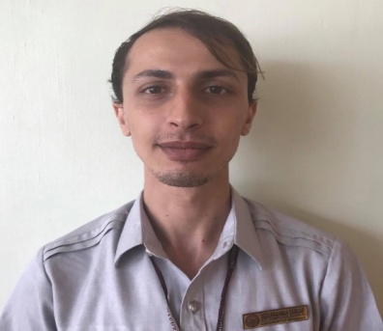

**Abdurrahman Samgar**

Address 1: Matina  
Address 2: Davao City 8000  
Mobile:+639926036924   
Email: smgrjr01@gmail.com

| EDUCATION |  |
| --- | --- |
| **BS-Computer Science – University Of Mindanao** | 2016-Present |

| ELIGIBILITY & CERTIFICATIONS |  |
| --- | --- |
| * Microsoft Software Specialist | 2017 |

| TRAININGS / SEMINARS / CONFERENCES |  |
| --- | --- |
| A. PARTICIPANT   * **Cybersecurity Caravan**   Ateneo de Davao University, Davao City | July 30, 2017 |

\



**University of Mindanao**

College of Computing Education

**F. Certificates**

